Date: September 30, 2019
To: Weber County Board of County Commissioners

From: Sean Wilkinson, Director
Community Development Department

Agenda Date: October 8, 2019

Subject: Request for Approval of a Lease Agreement Between Weber County and the Ogden Valley Recreation/Transmission Special Service District

Exhibits: A – Map of Lease Property
B – Lease Agreement

_____________________________________________________________________________________

Summary:
For the last few months, Weber County has been working with the Ogden Valley Recreation/Transmission Special Service District (District) on a new lease agreement for tower space and area for a building and equipment on County owned property in Eden. The property is located on a hill east of Snowflake Subdivision with access from Powder Mountain Road (see Exhibit A). It currently houses communication equipment for the Sheriff’s Office and television translator equipment for the District.

The lease agreement requires the District to pay 33% of the monthly utility costs to Weber County. The agreement runs for five years beginning on November 1, 2019, with automatic five-year extensions unless either party terminates the agreement in writing.

Recommendation:
Approve the Lease Agreement with the Ogden Valley Recreation/Transmission Special Service District.

Fiscal Impact:
The Ogden Valley Recreation/Transmission Special Service District will pay 33% of the monthly utility costs to Weber County.

Exhibit A

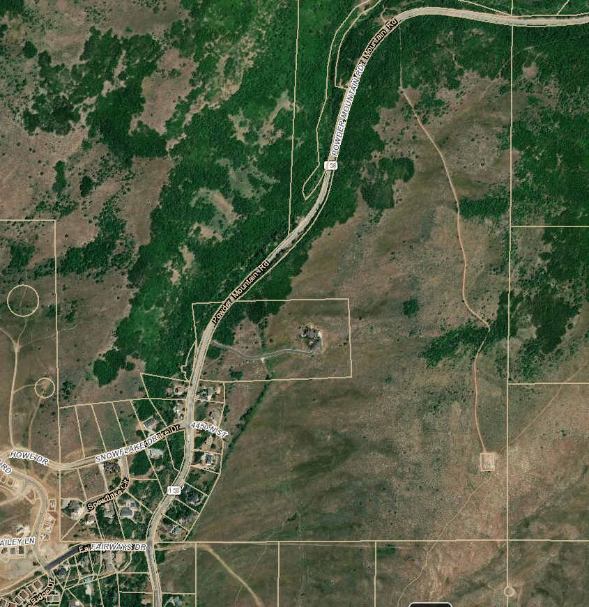
Tower Access Road
Tower Location

Exhibit B

LEASE AGREEMENT BETWEEN WEBER COUNTY AND THE OGDEN VALLEY RECREATION/TRANSMISSION SPECIAL SERVICE DISTRICT

This lease agreement is made and entered into on the 8th day of October, 2019, by and between Weber County, a body politic, corporate, and political subdivision of the State of Utah (“County”) and Ogden Valley Recreation/Transmission Special Service District, a special service district in the State of Utah (“District”).

RECITALS

WHEREAS, County owns the parcel of land identified as Tax Parcel No. 22-006-0036, which is more fully described in Exhibit A, and situated on the Property is a tower used for receiving and broadcasting signals (“Property”); and

WHEREAS, District provides recreational services, specifically television transmission services, to residents of the District; and

WHEREAS, District requires space on the tower that is on County’s Property in order to transmit television signals to the residents of the District;

NOW, THEREFORE, it is hereby acknowledged and agreed by the parties hereto as follows:

SECTION ONE
LEASE OF SPACE TO DISTRICT

A. County hereby leases to District a portion of the space on County’s tower as currently occupied, in addition to the added equipment relocated from the previous tower, together with a portion of the land for the installation and maintenance of District’s equipment not to exceed 450 Sq. Ft.

B. County also leases to District a non-exclusive right of way for ingress and egress extending from the nearest public right-of-way, Powder Mountain Road, to the Property.

C. In addition to space on the tower for District’s own equipment, District shall have the right to continue renting space on the tower to a paging company named SPOK. District has the right/option to replace SPOK with a similar type of renter so long as the space used by the renter does not exceed the space currently used by SPOK and so long as the renter’s equipment does not interfere with County’s equipment or any other renter’s equipment.

D. District and District’s renter shall utilize equipment only of the type and frequency that will not cause harmful interference to any of County’s equipment or any other renters of the Property.

SECTION TWO
RENT, TERM, AND MAINTENANCE

A. District shall pay County 33% of the cost of utilities per month for the leased space.

B. County shall maintain the site including the tower, generator, air conditioning to the County building, and the road leading to the site. District shall notify the County if the road or anything on the Property requires maintenance.

C. District shall maintain all of its equipment including the air conditioning to its building and any other equipment required by District to provide it services. District may upgrade or replace equipment as necessary so long as the new equipment does not exceed the space currently used. District shall be responsible for any negligent and/or intentional damage to the Property and any equipment on the Property.

D. This agreement shall be effective as of November 1, 2019 and shall continue thereafter until October 31, 2024. This agreement shall be automatically extended for additional five-year terms unless either party terminates it at the end of the then current term by giving the other party written notice of the intent to terminate at least 180 days prior to the end of the current term.

E. District agrees that upon expiration or termination of this agreement District shall remove its buildings, antennas, equipment, conduits, fixtures, and all personal property and restore the Property to its original condition, reasonable wear and tear excepted.

F. District shall have access to the Property at all times for the purpose of installing and maintaining its equipment; however, the parties acknowledge and agree that the access road to the Property is not plowed during the winter months. During the winter months when there is limited access, the County will provide transportation to the site. In case of emergency, transportation will be provided within 48 hours of receiving notice.

G. County shall remove the District’s antennas from the old tower and re-install those antennas on the new tower at County expense. County shall then remove the old tower.

SECTION THREE
INSURANCE AND NOTICES

A. District’s Insurance. District will maintain at its own cost: (i) Commercial General Liability insurance with limits not less than $1,000,000 for injury to or death of one or more persons in any one occurrence and $500,000 for damage or destruction to property in any one occurrence; (ii) Commercial Auto Liability insurance on all owned, non-owned and hired automobiles with a minimum combined limit of not less than one million ($1,000,000) per occurrence; (iii) Workers Compensation insurance for any employees providing the statutory benefits and not less than one million ($1,000,000) of Employers Liability coverage.

B. County’s Insurance. County is a participating member of the Utah Counties Indemnity Pool (UCIP), a joint reserve fund authorized in accordance with the provisions of UCA 63G-7-703. County agrees to maintain at its own cost commercial general liability coverage with limits not less than $1,000,000 for injury to or death of one or more persons in any one occurrence and $500,000 for damage or destruction to property in any one occurrence.

C. Notices. It is agreed that all notice required or permitted to be given hereunder, for all purposes of billing, process, correspondence, and all other legal purpose whatsoever shall be deemed to be sufficient, if given in writing by United States Mail, postage prepaid, and registered or certified, addressed as follows:

(1) To County: Weber County Commission
2380 Washington Blvd.
Ogden, UT 84401

With a copy to: Weber County Attorney’s Office
Civil Department
2380 Washington Blvd. Suite 230
Ogden, UT 84401-1464

Or such other address as the County may have advised the District in writing.

(2) To District: Ogden Valley Recreation/Transmission SSD
P.O. Box 336
Eden, UT 84310

Or at such other address as District may have advised the County in writing.

SECTION FOUR
DEFAULT

A. Default. In the event of a breach by a party with respect to any of the provisions of this agreement, the non-defaulting party shall give written notice of such breach to the defaulting party. After receipt of such written notice, the defaulting party shall have 15 days in which to cure any breach provided that the defaulting party shall have such extended period of time as may be required beyond the 15 days if the nature of the cure is such that it reasonably requires more than 15 days and the defaulting party commences the cure within the 15 day period and thereafter continuously and diligently pursues the cure to completion.

B. Remedies. Upon a default, the non-defaulting party may at its option (but without obligation to do so) perform the defaulting party’s duty or obligation on the defaulting party’s behalf. The costs and expenses of any such performance by the non-defaulting party shall be due and payable by the defaulting party upon invoice therefor. In the event of a default by either party that is not timely cured as outlined above, the non-defaulting party may terminate the agreement.

SECTION FIVE
MISCELLANEOUS

A. Entire Agreement. This agreement, with referenced documents, constitutes the entire agreement by and between the parties and no other statement, whether written or oral, shall be deemed a part of this agreement unless specifically incorporated herein by reference. This agreement supersedes any and all other agreements, negotiations, or understandings between the parties. This agreement may not be amended except as agreed upon in writing by both parties.

B. Indemnification. Each party shall indemnify and hold the other harmless against any claim of liability or loss from personal injury or property damage resulting from or arising out of the negligence or willful misconduct of the indemnifying party, its employees, contractors or agents, except to the extent such claims or damages may be due to or caused by the negligence or willful misconduct of the other party, its employees, contractors, or agents.

C. Assignment and Sublet. Sub-lease operation cannot interfere with the District’s television signals. Any interference has to be rectified at the expense of the sub-lessee in a timely manner to the satisfaction of the District.

D. Paragraphs and Headings. The paragraph and other headings of this agreement are for reference purposes only and shall not be deemed to alter the meaning or intent of the language of this agreement exclusive of such headings.

E. Governing Law. The laws of the State of Utah shall govern the validity, construction, enforcement, and interpretation of this agreement.

F. Counterparts. This agreement may be executed in counterparts such that, if two or more copies hereof, when taken together, bear the signatures of all parties hereto, such copies shall constitute one agreement.

G. Duplicate Originals. This agreement may be executed in duplicate originals.

H. Severability. The invalidity of any portion of this agreement will not and shall not be deemed to affect the validity of any other provision. If any provision of this agreement is held to be invalid, the parties shall replace the invalid provision with language that most closely meets the intent of the parties in agreeing to the invalid provision.

I. No Waiver. The failure of either party to this agreement to insist upon the performance of any of the terms and conditions of this agreement, or the waiver of any breach of any of the terms and conditions of this agreement, shall not be construed as subsequently waiving any such terms and conditions, but the same shall continue and remain in full force and effect as if no such forbearance or waiver had occurred.
IN WITNESS WHEREOF, the undersigned have affixed their respective signatures hereto.

BOARD OF COUNTY COMMISSIONERS
OF WEBER COUNTY

By_________________________________
Scott K. Jenkins, Chair
ATTEST:

___________________________________________
Ricky Hatch, CPA
Weber County Clerk/Auditor

DISTRICT:

By_________________________________
Richard G. Menzies, Chair

ATTEST:

__________________________________________
Exhibit A
(Legal Description of Parcel Number 22-006-0036)

PART OF THE SOUTHEAST QUARTER OF SECTION 15, TOWNSHIP 7 NORTH, RANGE 1 EAST, SALT LAKE BASE & MERIDIAN, US SURVEY BETTER DESCRIBED AS FOLLOWS: BEGINNING AT A POINT THAT FALLS NORTH 0026'18" EAST 691.66 FEET ALONG THE SECTION LINE AND NORTH 89D47'26" WEST 142.38 FEET FROM THE BRASS MOUNUMENT LOCATING AT THE SOUTHEAST CORNER OF SAID SECTION 15, BASIS OF BEARING BEING THAT OF NAD 83 UTAH NORTH STATE PLANE GRID BETWEEN THE SAID SOUTHEAST CORNER AND THE EAST QUARTER CORNER OF SECTION 15 AND RUNNING THENCE SOUTH 87D30'30" WEST 56.03 FEET THENCE NORTH 88D08'24" WEST 91.67 FEET, THENCE NORTH 00D12'34" EAST 147.60 FEET, THENCE SOUTH 89D47'26" EAST 147.60 FEET THENCE SOUTH 00D12'34" WEST 147.60 FEET TO THE POINT OF BEGINNING. CONTAINS 0.50 ACRES.

