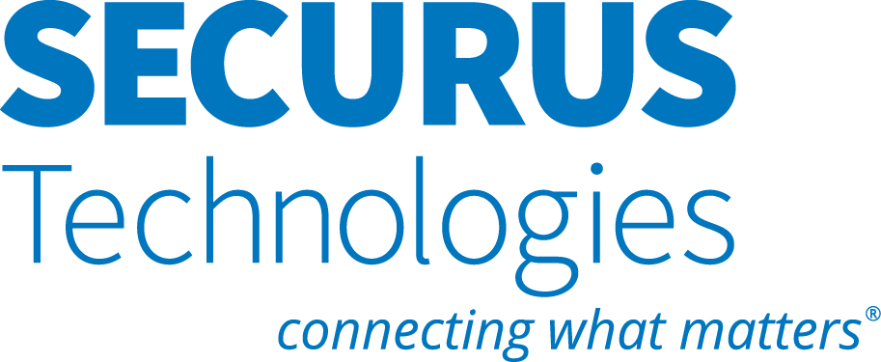

SECOND AMENDMENT TO

MASTER SERVICES AGREEMENT
This SECOND AMENDMENT (“Second Amendment”) is effective as of the last date signed by either party (“Second Amendment Effective Date”) and amends and supplements that certain Master Services Agreement by and between Securus Technologies, LLC (F/k/a Securus Technologies, Inc.) (“we,” “us,” or “Provider”) and the Weber County Correctional Facility (“you” or “Customer”) dated July 14, 2017, as subsequently amended (collectively, the “Agreement”).
WHEREAS Customer and Provider are parties to the Agreement and desire to amend the terms as stated herein;
NOW, THEREFORE, as of the Second Amendment Effective Date and in consideration of the mutual promises and covenants contained herein, the parties agree as follows:
- Term. This Second Amendment shall commence on the Second Amendment Effective Date and shall remain in effect through the Term of the Agreement. Further, the Term of the Agreement shall be extended by 48 months and will end on November 14, 2027. Notwithstanding anything to the contrary, the terms and conditions of the Agreement shall continue to apply for so long as we continue to provide the Applications to you after the expiration or earlier termination of this Agreement.
- Tablets. As of the Second Amendment Effective Date, Provider will deploy free basic community tablets to Facility. In addition to the free basic community tablets, Provider will offer personal rental tablets with premium content. Provider will offer one tablet per inmate based on the Customer’s Average Daily Population. The Customer may purchase tablet earbuds at $5.66 per set, which may be invoiced or deducted from commissions. Customer is responsible for any applicable taxes and third-party expenses associated with the earbud purchase. Each earbud order must be for at least 25 units and be made in 25 unit increments. Provider may, at its option, decline to fulfill any order that does not conform to these requirements. Alternatively, if requested by Customer, Provider will work with Customer’s commissary provider to facilitate the sale of earbuds. Customer will not permit the resale of the earbuds for more than $19.99 per set unless approved by Provider.
Premium content may include, but is not limited to, songs, games, movies, and television episodes. Customer understands and acknowledges that premium content is subject to availability and may change at Provider’s discretion. Premium content also may be subject to third-party licensing agreements with content providers. If Customer provides content for Provider to display on the tablets, Customer represents and warrants that it has obtained all necessary licensing and rights to display such content. Provider is not responsible and hereby disclaims any liability for any and all content of third-party applications and any documents, videos, or forms published by Customer or from outside sources.
For the 12-month period following the Effective Date, Provider will offer personal rental tablets at a promotional rate of $5.00 per tablet per month plus applicable taxes/fees/surcharges. Provider will pay Customer 20% commission on the revenue earned through the purchase of premium content on those tablets; such commission is net of licensing and network costs, excludes applicable taxes/fees/surcharges, and is not paid on the tablet rental rate. The subscription fee and premium content fees can be paid by using either Inmate Debit or a Tablet user account. The parties reserve the right to renegotiate the $5.00 promotional rental rate and/or commissions earned if, after the initial 12-month period, Provider’s Tablet-related costs exceed the revenue generated.
TERMS & CONDITIONS:
Customer represents and warrants that it will not provide the Tablet to inmates whom Customer knows or reasonably suspects pose a threat to other inmates or Facility personnel, or who may use an Inmate Tablet in a dangerous or unauthorized manner.
Customer understands and acknowledges that premium content is rented and available only for the duration of an inmate’s incarceration at the Facility and will not be made available upon the inmate’s release.
Customer further understands and acknowledges that, in instances where inmate telephone calls originate from Tablets, Investigator Pro™ works only with Provider’s certified earbuds. If Customer elects to sell alternative earbuds, Customer forgoes the effectiveness of Investigator Pro’s™ voice identification technology on Tablet calls. Moreover, Customer will refrain from the sale or distribution of earbuds with a microphone other than Provider’s certified earbuds.

IN NO EVENT WILL PROVIDER BE LIABLE FOR ANY INDIRECT, INCIDENTAL, OR CONSEQUENTIAL DAMAGES, HOWEVER ARISING, INCURRED BY CUSTOMER OR INMATE FROM RECEIPT OR USE OF THE TABLET OR THE UNAVAILABILITY THEREOF.
Customer hereby agrees to protect, indemnify, defend, and hold harmless Provider from and against any and all costs, claims, demands, damages, losses, and liabilities (including attorneys' fees and costs) arising from or in any way related to Customer’s or inmates’ negligent use of the Tablet.
Provider hereby agrees to protect, indemnify, defend, and hold harmless Customer from and against any and all costs, claims, demands, damages, losses, and liabilities (including attorneys’ fees and costs) caused by Provider’s negligence.
- Customer Options for Alternative Compensation Structures. Notwithstanding anything to the contrary in the Agreement, at Customer’s option, Customer may request that compensation and rates under the Agreement be amended to either a no commission or taxpayer-funded and no commission option at any time during the Term. If requested by Customer, the parties will negotiate in good faith regarding an appropriate reduction to the applicable call rates if Customer agrees to no longer receive any commission or other type of financial compensation under the Agreement. For such compensation structures, Provider can also accommodate a Customer request to transition from inmate and friend and family funding of inmate telephone services to a model where those services are taxpayer-funded / paid for by Customer.
- Addition to Miscellaneous Terms. If any legal action or other proceeding is brought for the enforcement of the Agreement or because of an alleged dispute, breach, default, or misrepresentation in connection with any provisions of the Agreement, the successful or prevailing party or parties shall be entitled to recover from the non-prevailing party, reasonable attorneys' fees, court costs, and all expenses, even if not taxable as court costs (including, without limitation, all such fees, costs, and expenses incident to appeals), incurred in that action or proceeding, in addition to any other relief to which such party or parties may be entitled. As used herein, “prevailing party” includes without limitation, a party who dismisses an action for recovery hereunder in exchange for payment of the sums allegedly due, performance of covenants allegedly breached, or consideration substantially equal to the relief sought in the action.
- Except as expressly amended by this Second Amendment, all of the terms, conditions and provisions of the Agreement shall remain in full force and effect. All capitalized terms used but not defined herein shall have the meaning set forth in the Agreement.
EXECUTED as of the Second Amendment Effective Date.
CUSTOMER:  Weber County Correctional Facility  By:  Name:  Title:  Date: | PROVIDER:  Securus Technologies, LLC  By:  Name: _______________________________________  Title: _______________________________________  Date:

Please return signed contract to:
4000 International Parkway
Carrollton, Texas 75007
Attention: Contracts Administrator
Phone: (972) 277-0300

