|  |  |
| --- | --- |
| **WC Logo.emf** | **Staff Report to the Weber County Commission**  *Weber County Planning Division* |
|  | |

****Synopsis****

****Application Information****

**Application Request:** A public hearing to consider and take action on a request to vacate the 10-foot public utility easements located on both sides of the lot line between lots 63 and 64 of Durfee Creek Estates Number 2C.

**Agenda Date: Tuesday, March 23, 2021**

**Applicant:** Todd Oliver

**File Number:** EV2021-02

****Property Information****

**Approximate Address: 2275 E 6745 N**, Liberty, 84310

**Project Area:** 2.98 Acres

**Zoning:** Forest (F-5)

**Existing Land Use:** Residential

**Proposed Land Use:** Residential

**Parcel ID:** 17-307-0004, 17-307-0005

**Township, Range, Section:** T8N, R1W, Section 36

****Adjacent Land Use****

**North:** Residential **South:** Residential

**East:** Residential **West:** Residential

****Staff Information****

**Report Presenter: Felix Lleverino**

flleverino@webercountyutah.gov

**801-399-8767**

**Report Reviewer:** SB

Development History

Durfee Creek Estates Number 2C was recorded in the Weber County Recorder’s Office on April 26, 2005.

Background and Summary

The applicant has submitted a request to vacate the 10-foot public utility easements located on both sides of the lot line between lots 63 and 64 of the Durfee Creek Estates Number 2C. The property owner is requesting the vacation of the public utility easement to allow for the placement of a single-family-dwelling. The owner has obtained easement release letters from the Durfee Creek HOA, Rocky Mountain Power, and Questar Gas Company.

The applicant has proposed to vacate the public utility easement by ordinance and amended plat. Under Utah State Code, Section 17-27a-609.5, the legislative body may adopt an ordinance granting a petition to vacate some or all of a public street, right-of-way, or easement if the legislative body finds that:

(a) good cause exists for the vacation; and

(b) neither the public interest nor any person will be materially injured by the vacation.

The vacating procedure found in Utah State Code 17-27a-208 and 17-27a-209.5 does not require a Planning Commission recommendation.

The following is the staff's analysis of the vacation request.

Analysis

*General Plan*: Vacating this easement does not conflict with the Ogden Valley General Plan.

*Additional Standards*: Utah State notice procedures (17-27a-208) have been followed for this petition to vacate. Any comments or objections to this proposal may be heard before or during a public hearing that is being held on March 23, 2021.

*Agency Review*: Engineering is ready to approve this vacation. Planning will record the ordinance and amended plat after the 15-day waiting period has lapsed and all affected entities approved of it.

Staff Recommendation

Staff recommends approval of the request to vacate the 10-foot public utility easements located on both sides of the lot line between lots 63 and 64 of Durfee Creek Estates Number 2C. This recommendation for approval is subject to all review agency requirements and is based on the following condition:

1. The ordinance to vacate the public utility easement will be recorded.

This recommendation for approval is based on the following findings:

1. Vacating the proposed easement does not conflict with the Ogden Valley General Plan.
2. The public interest or any person will not be materially injured by the proposed vacation.
3. The proposed vacation will not be detrimental to public health, safety, or welfare.
4. The proposed vacation will not deteriorate the environment of the general area to negatively impact surrounding properties and uses.
5. Rocky Mountain Power, Questar Gas, and the Durfee Creek Estates HOA approve of this vacation.

Exhibits

1. Durfee Creek Estates No 2C Plat
2. Durfee Creek Estates No 2C, 2nd Amendment Plat
3. Proposed areas to be vacated
4. Vacation ordinance**11kfjf**

Area Map

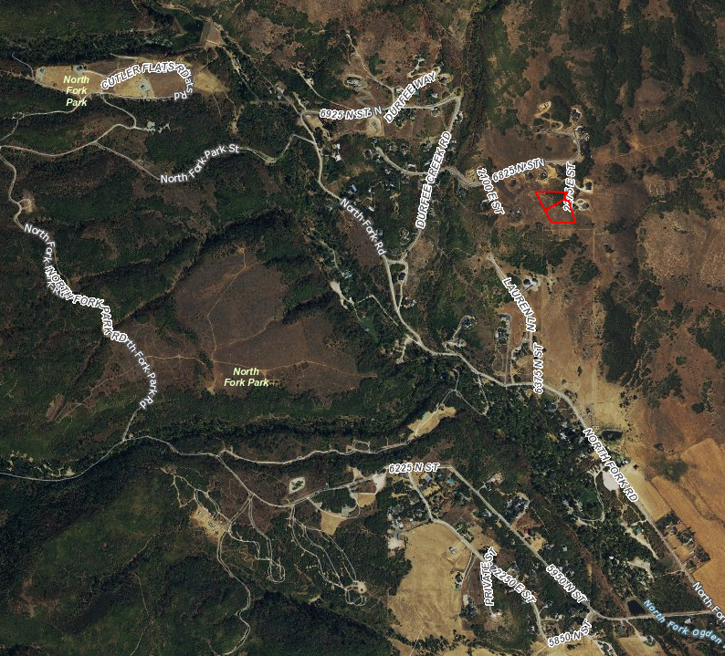

Exhibit A

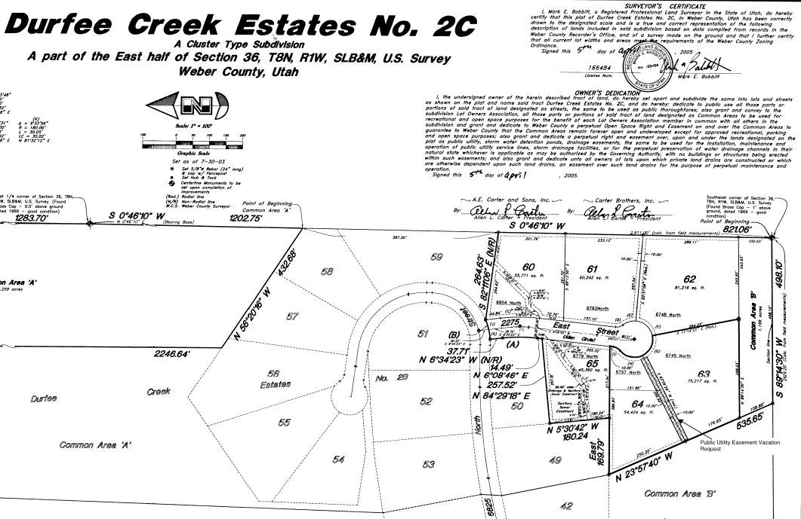

Exhibit B

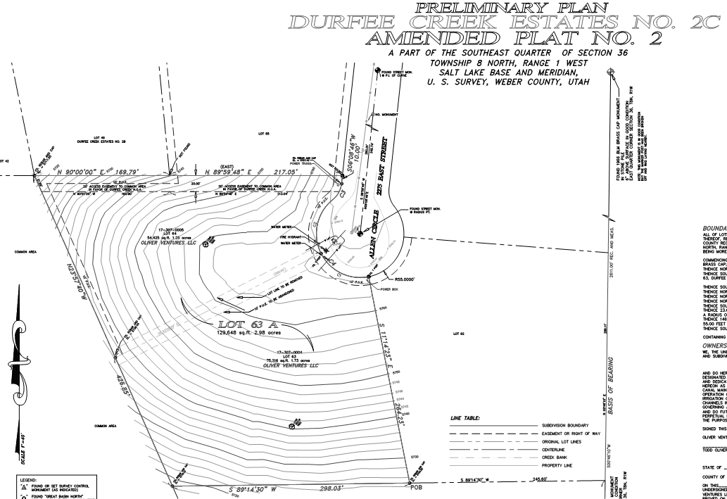

Exhibit C

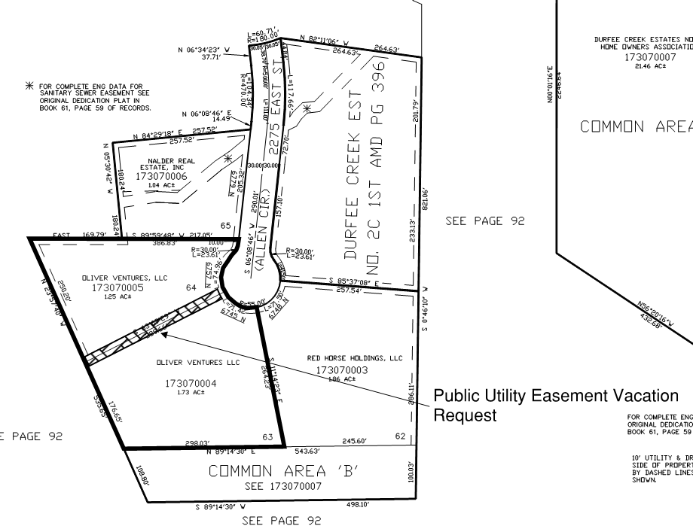

Exhibit D

**Ordinance**

**An ordinance of Weber County vacating the 10-foot public utility easements located on both sides of the shared line of lots 63 and 64 of Durfee Creek Estates Number 2C**

**Whereas**, the residential lot 63 and 64 are described in a plat named “Durfee Creek Estates No 2C,” recorded in the Weber County Recorder’s Office on April 26th, 2005 as Entry number 2099199; and

**Whereas,** Todd and Kristin Oliver, the legal lot owners of Lots 63 and 64 of the Durfee Creek Estates Number 2C, have filed a petition to vacate the 10-foot public utility easements located on both sides of the shared line of lots 63 and 64 of Durfee Creek Estates Number 2C; and

**Whereas,** after providing proper public notice, a public hearing was held on March 23rd, 2021, regarding the vacation of the 10-foot public utility easement located within Lots 63 and 64 of the Durfee Creek Etates No 2C; and

**Whereas,** The Weber County Engineering Department has been notified and has provided written approval of the vacation of the public utility easement located within Lots 63 and 64 of the Durfee Creek Estates; and

**Whereas,** the Board of County Commissioners finds that the vacation of the public utility easement within Lots 63 and 64 of the Durfee Creek Estates No 2C will not substantially affect the Ogden Valley General Plan or the health, safety, and welfare of the general public;

**Now, Therefore,** the Board of County Commissioners of Weber County ordains as follows: The following public utility easement located within Lots 63 and 64 of the Durfee Creek Estates Number 2C, which is described in Entry number of the Weber County Recorder’s Office, is hereby vacated from the subdivision:

**The 10-foot public utility easements located on both sides of the shared line of lots 63 and 64 of Durfee Creek Estates Number 2C, as highlighted with cross hatches on the 2021 Recorder’s plat (17-307) below, is hereby vacated from said lot.**

**This Ordinance shall be effective 15 days after publication in the Standard Examiner.**

Passed, adopted, and ordered published this day of , 2021, by the Board of County Commissioners of Weber County.

(*signatures on following page*)

BOARD OF COUNTY COMMISSIONERS OF WEBER COUNTY

By___________________________________

James H. “Jim” Harvey, Chair

Commissioner Harvey Voting

Commissioner Froerer Voting

Commissioner Jenkins Voting

ATTEST:

Ricky Hatch, CPA

Weber County Clerk

